1. Collect data on the number of commits and repositories created for each crypto project.
2. Rank the projects based on these metrics and graph the evolution of this ranking over time.

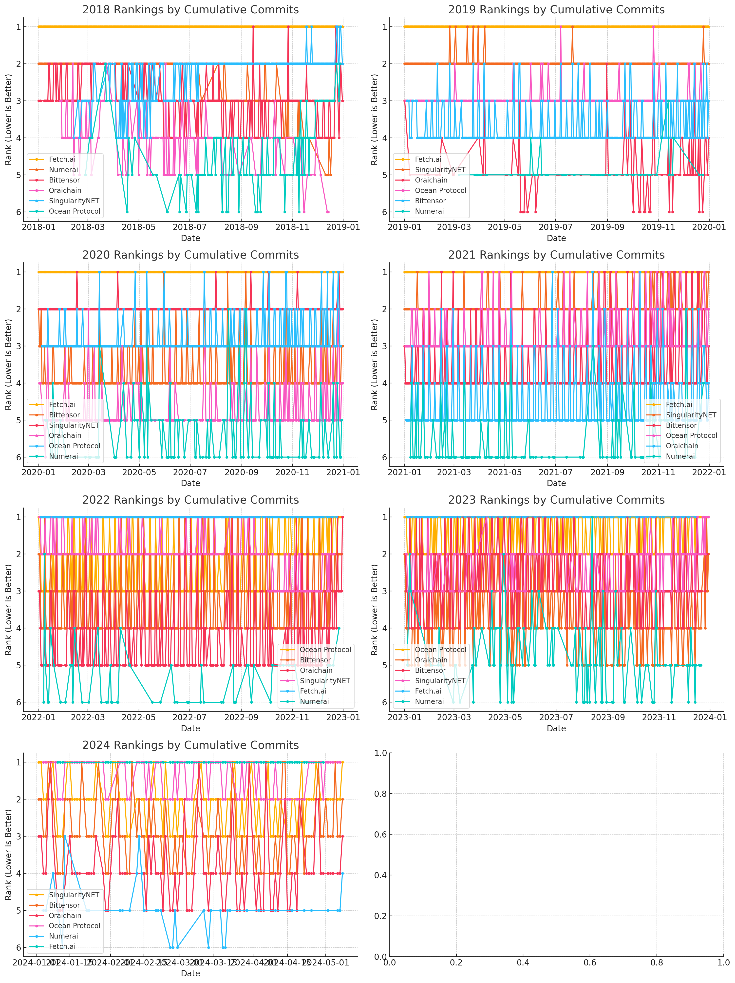

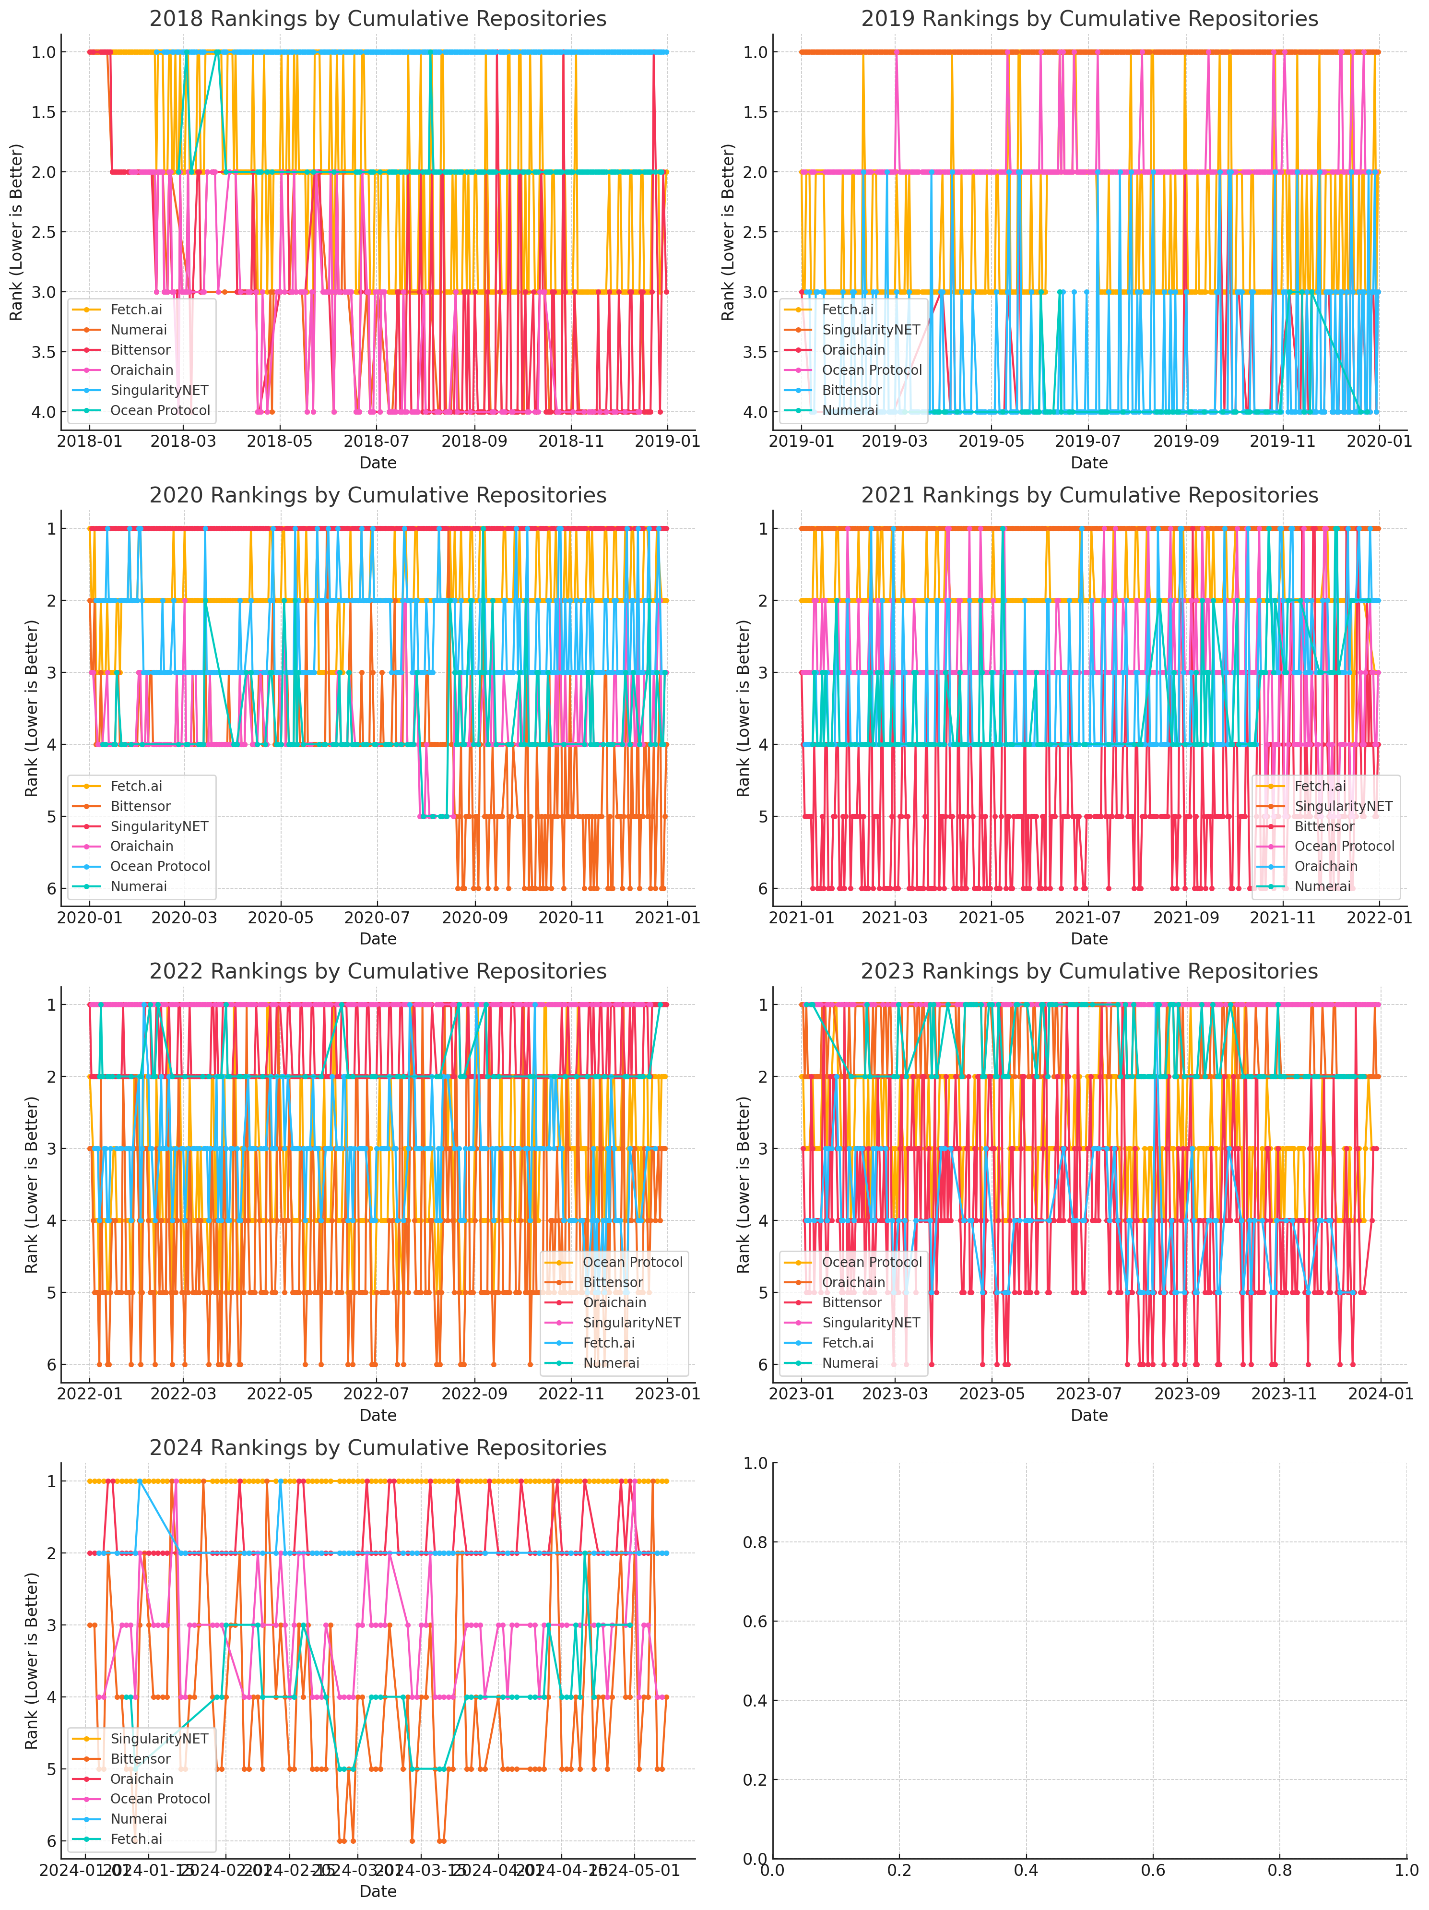

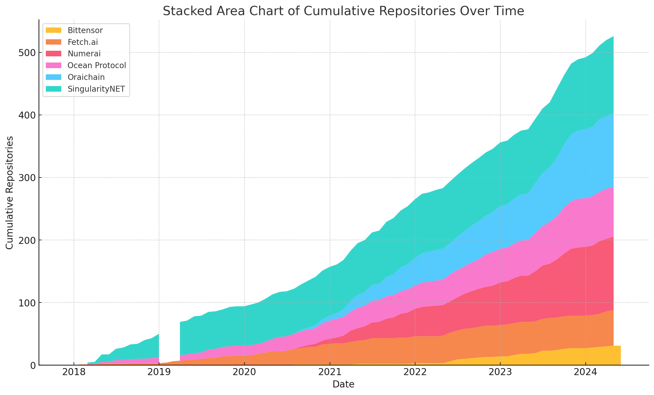

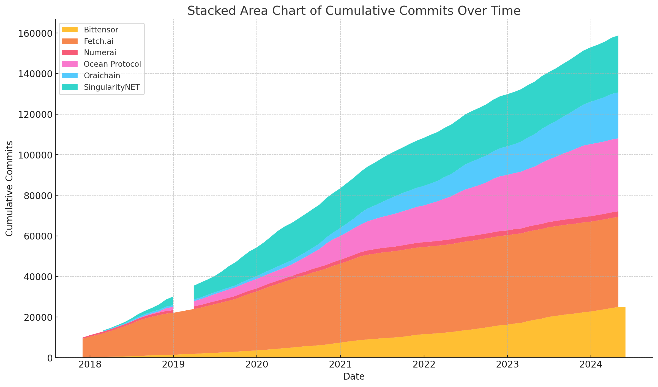

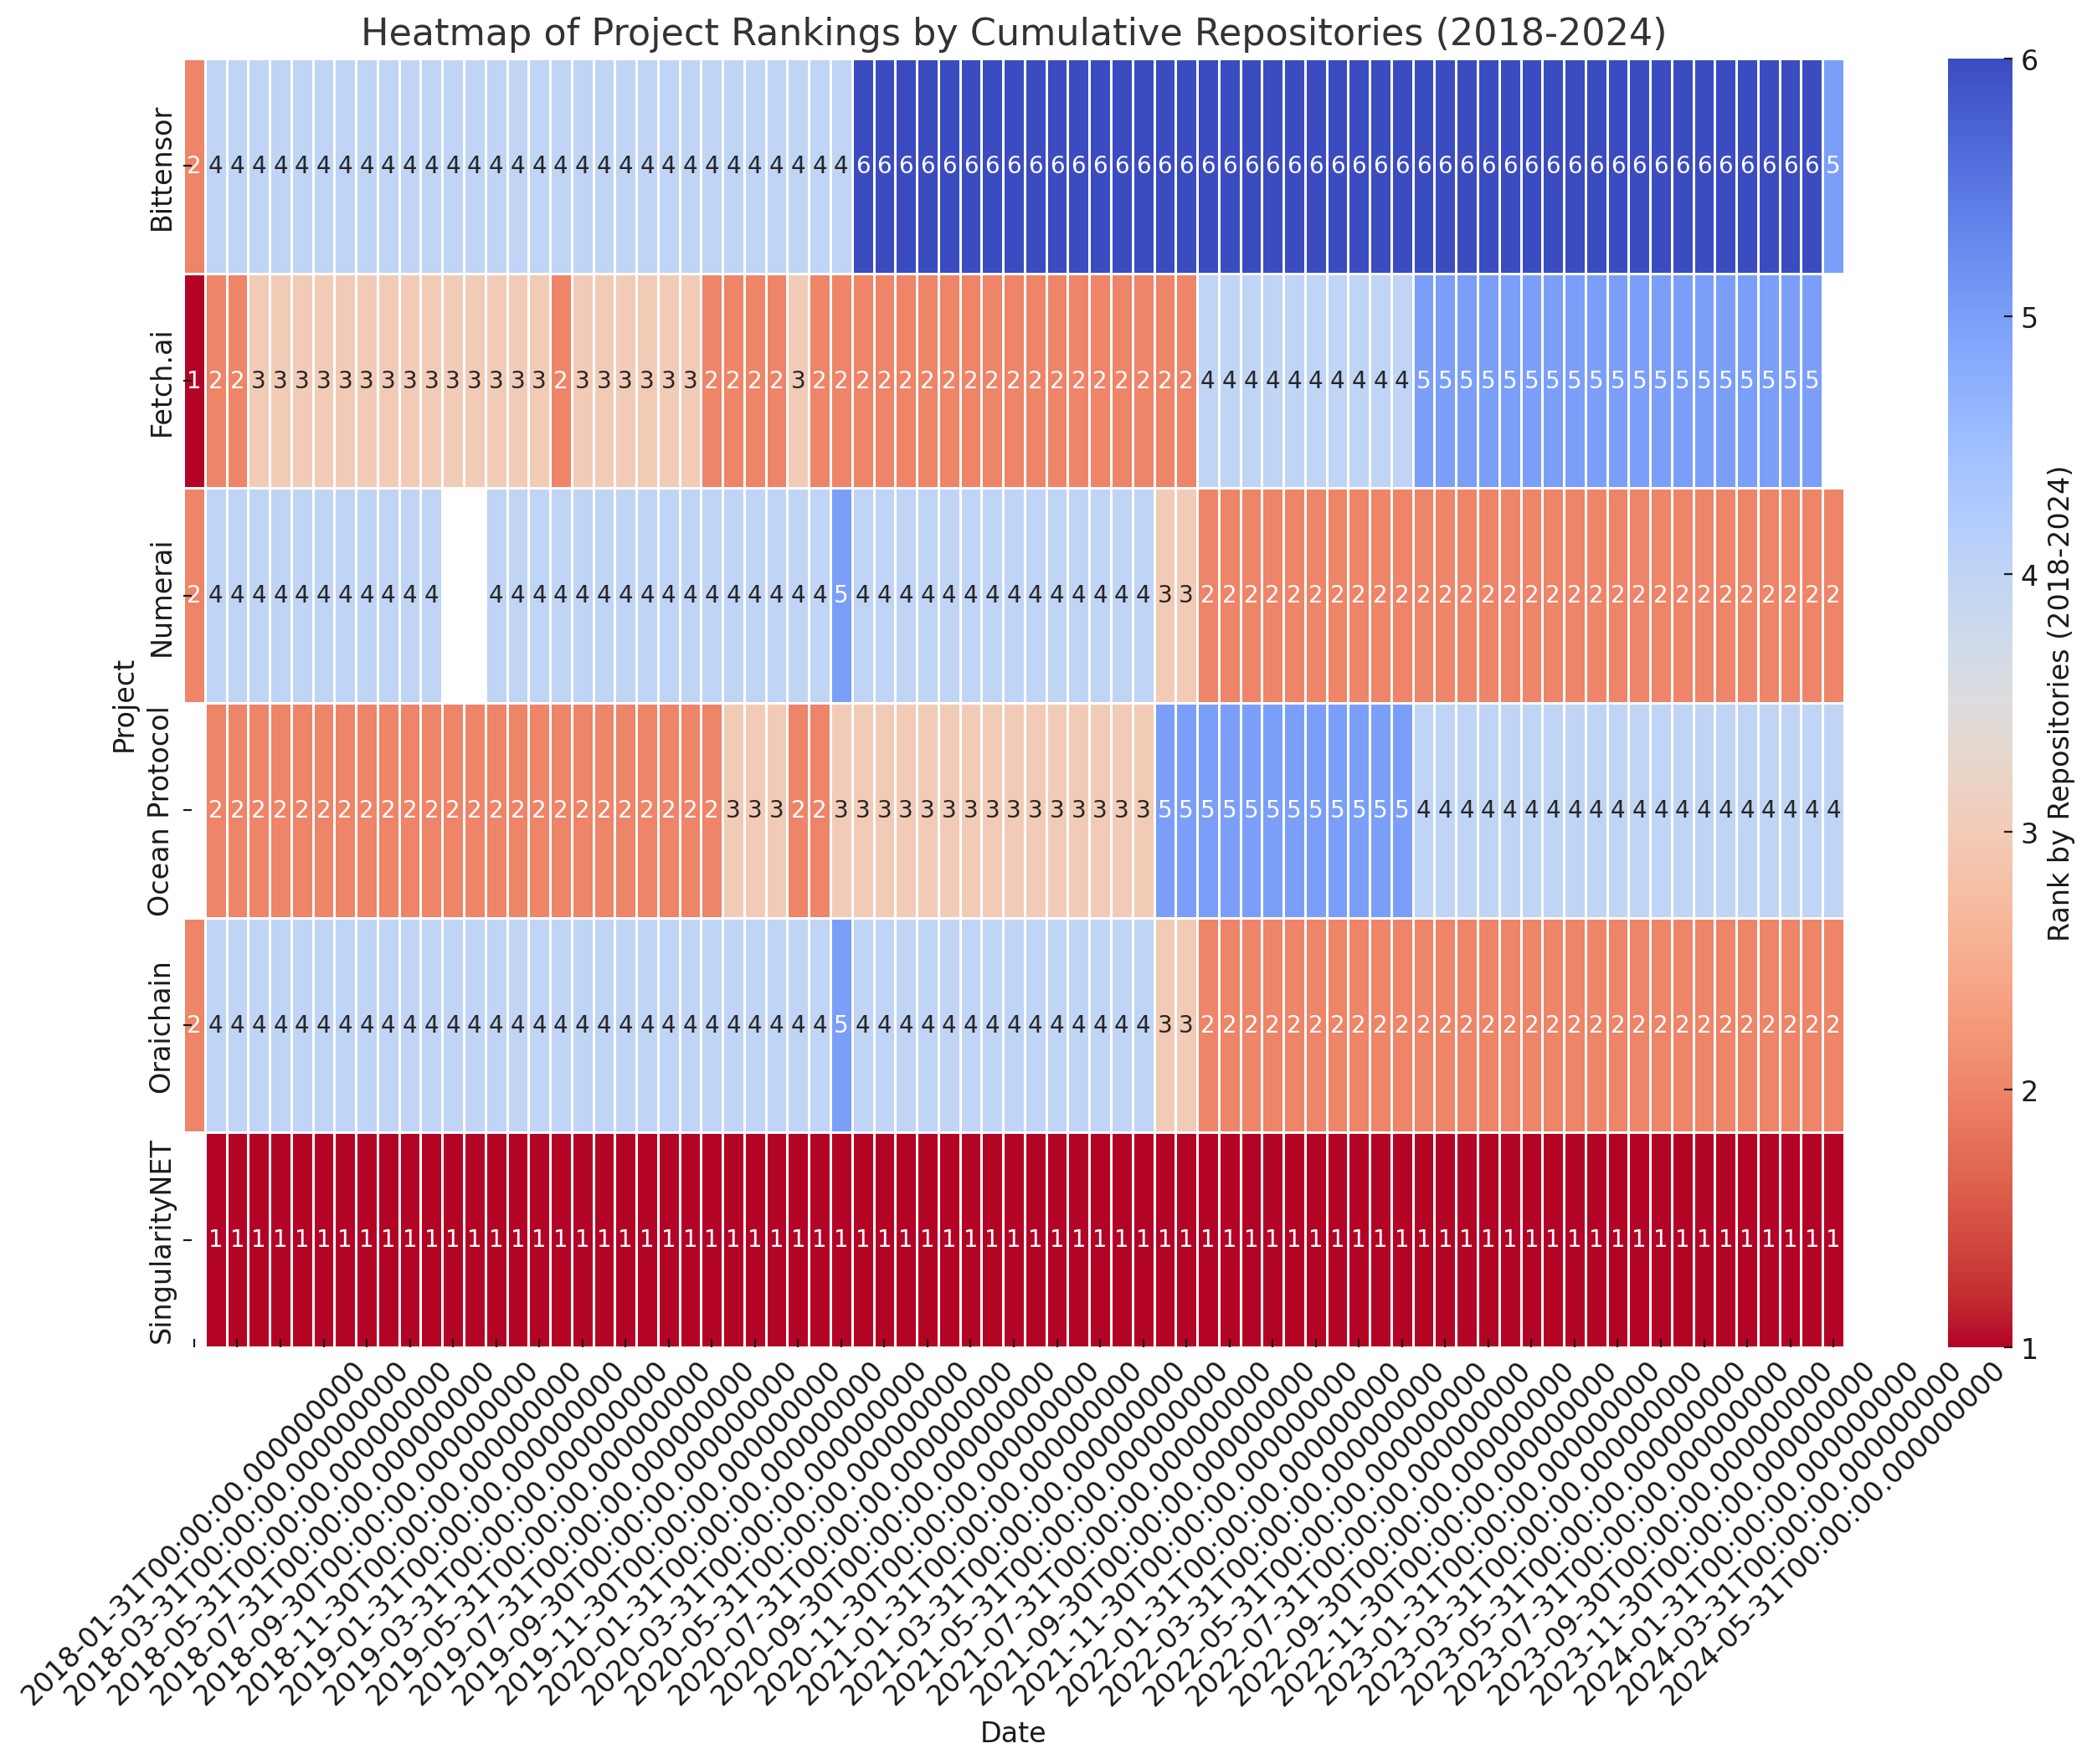

The heatmap above shows the rankings by cumulative commits from 2018 to 2024 for each project. The data is focused on the specified years, making it easier to observe trends and changes in rankings during this period.

Here’s the heatmap showing the rankings by cumulative repositories from 2018 to 2024. Similar to the heatmap for commits, this visualization provides insights into how each project ranks in terms of repository growth within this specific timeframe.

Both heatmaps focus on the years 2018 to 2024, offering a detailed view of project activity and changes in their relative positions over time.

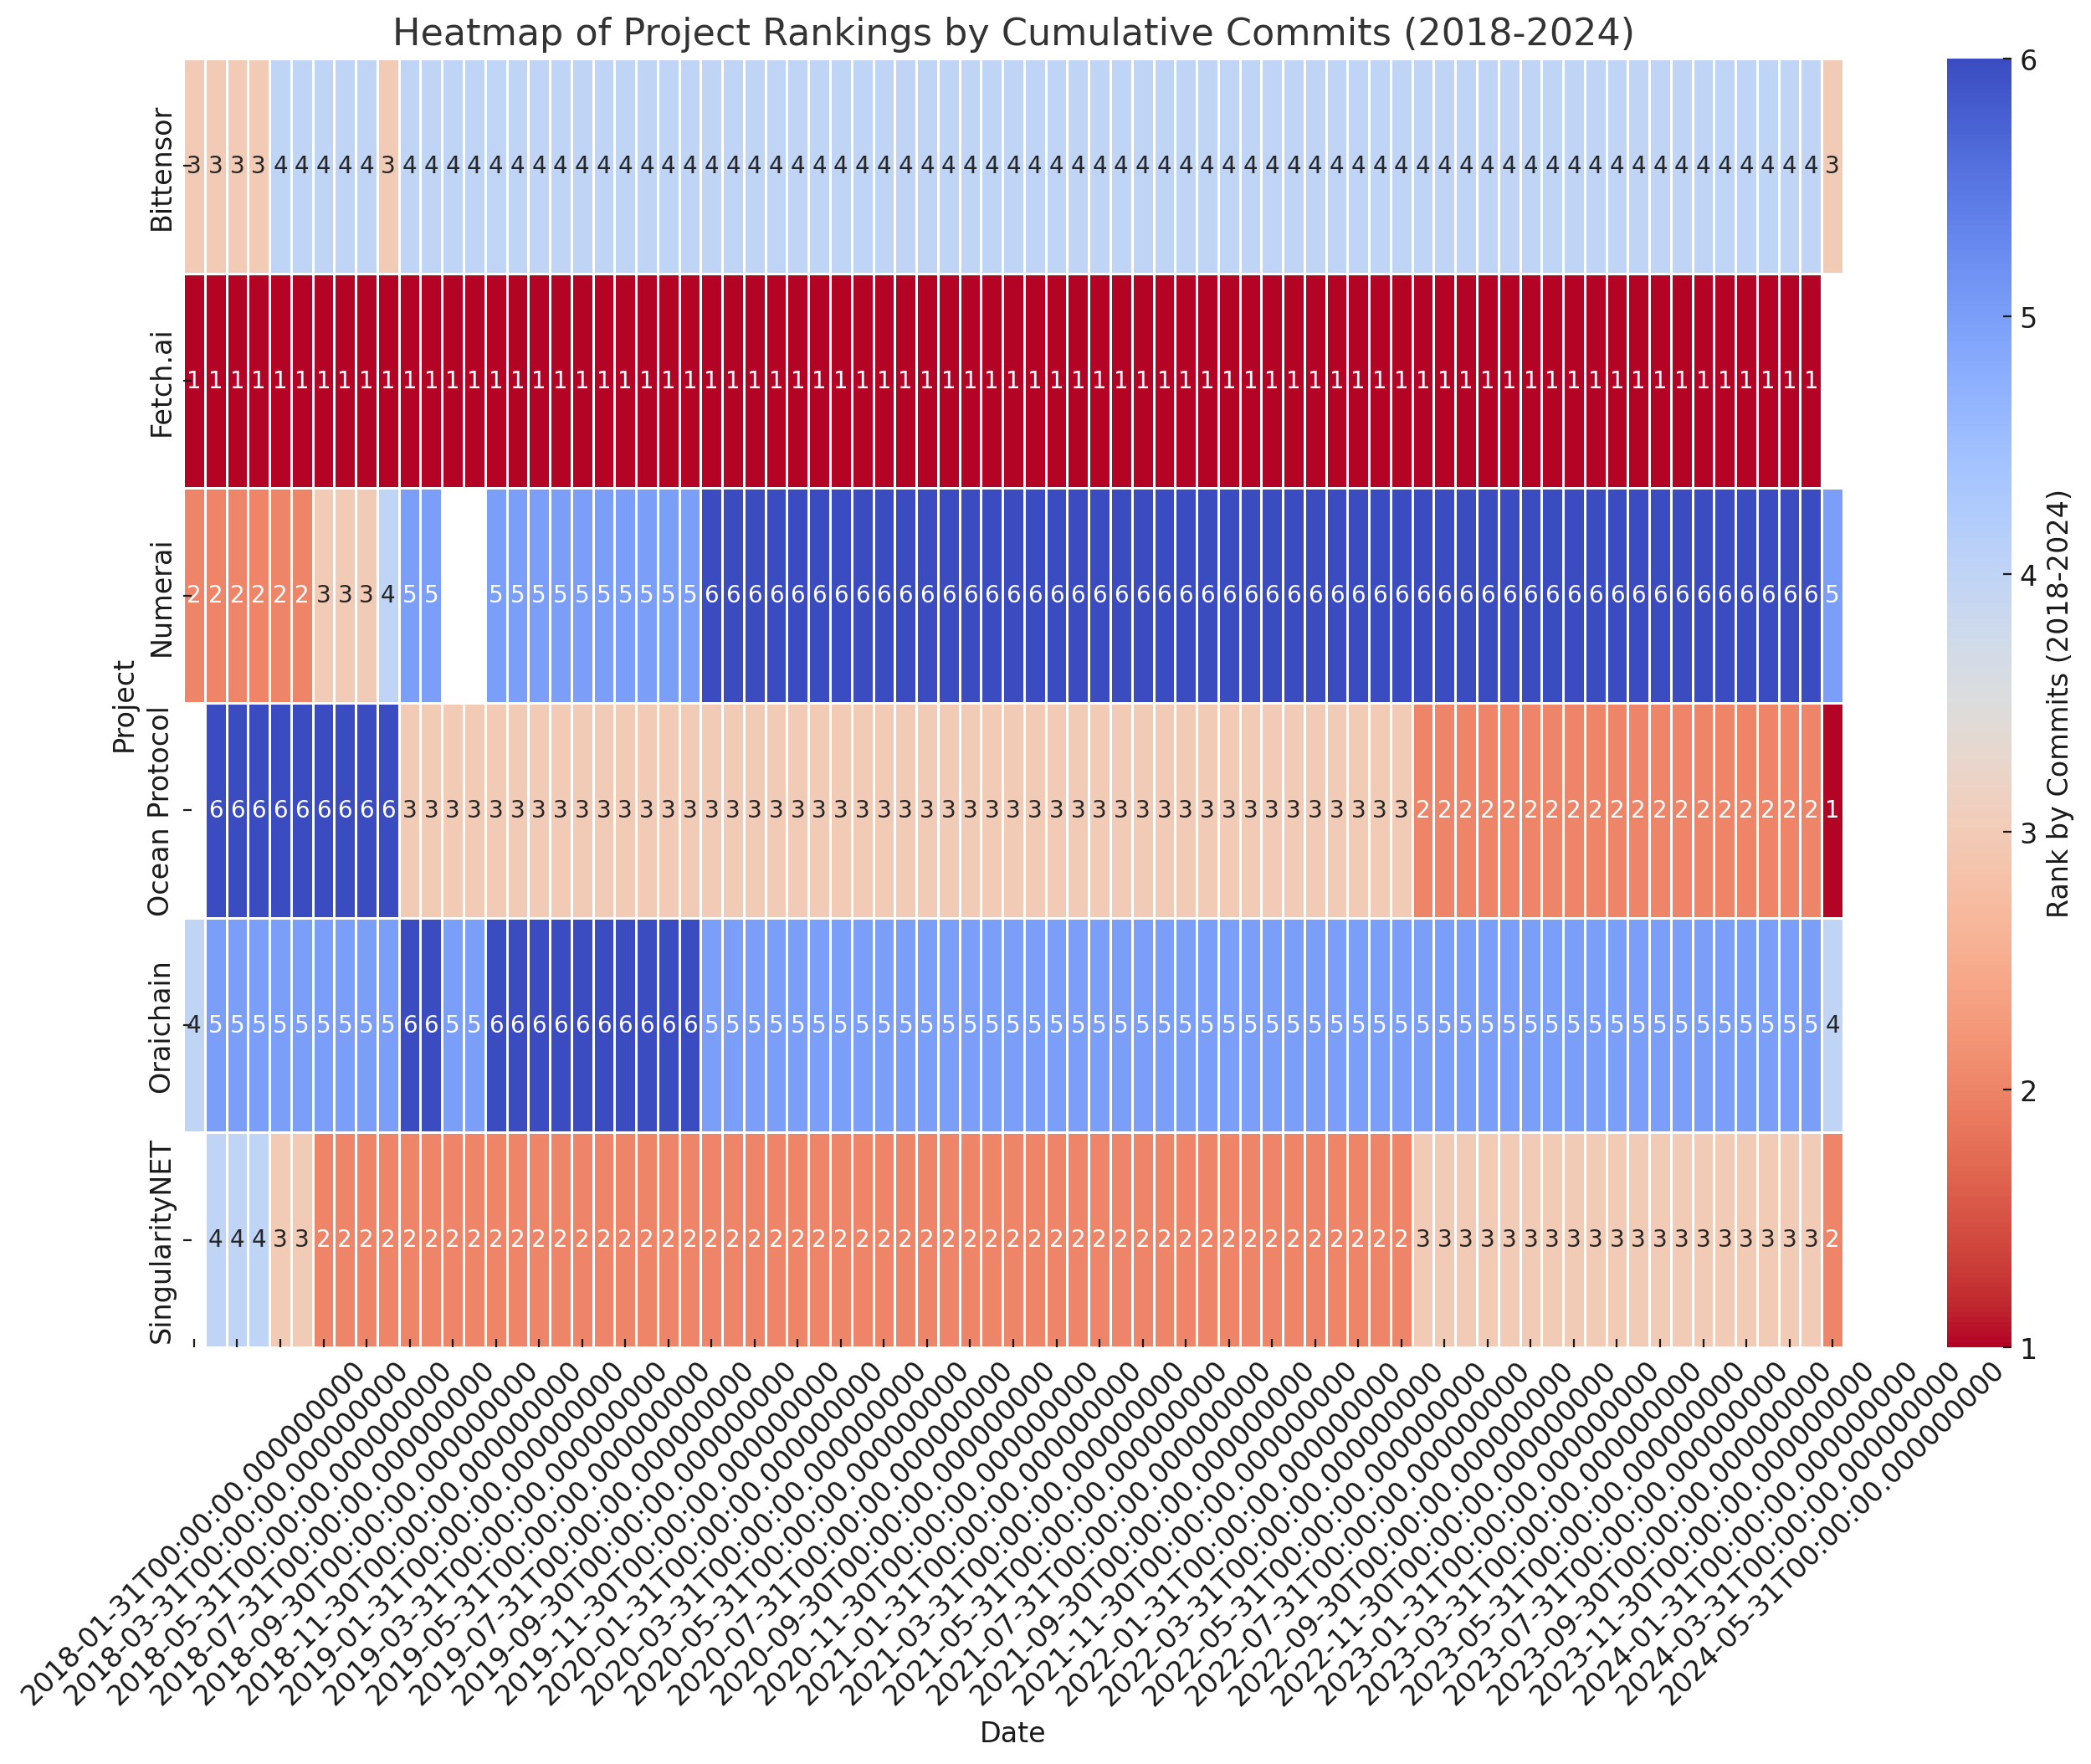

**Correlations**

* Use statistical methods to determine the correlation between developer activity and project token price.
* Analyze the correlation in different timeframes (short-term, medium-term, long-term) to understand if phases of high or low activity impact token price.

**Bittensor**

The data for Bittensor consists of:

* GitHub Stats: Tracks cumulative commits over time. It appears that the "Cumulative Repos" column may contain missing values.
* Token Price: Includes open, high, low, close, adjusted close prices, and volume for each day.

The merged dataset for Bittensor includes both the cumulative commits and token prices (open, high, low, close, adjusted close, volume). However, there's a noticeable issue with the token price data on March 5, 2023, where the price significantly diverges from subsequent days. This could be a data error or anomaly. It appears that there is a very low close price (0.126083) on March 5, 2023, which is significantly different from the other prices that start from around 34 and go up to several hundred. This anomalous value may skew our correlation analysis if left unaddressed.

1. Address any data errors or inconsistencies, particularly in the token price. 2.Calculate the correlation between the cumulative commits and the token prices (specifically, the daily closing price as a general representative of the token's value).
2. Explore the correlation in different timeframes (short-term, medium-term, long-term).

The Pearson correlation coefficient between cumulative commits and the closing price of the token for Bittensor is approximately 0.81. This indicates a strong positive correlation, suggesting that as developer activity (measured by cumulative commits) increases, the token price tends to increase as well.

Next, we can analyze the correlation in different timeframes:

1. Short-term: Last 1 month
2. Medium-term: Last 3 months
3. Long-term: Entire dataset timeframe

Here are the correlation coefficients between cumulative commits and closing token price across different timeframes for Bittensor:

1. Short-term (Last 1 month): −0.86
2. Medium-term (Last 3 months): −0.68
3. Long-term: 0.81

These results suggest:

1. In the long-term, there is a strong positive correlation, indicating that higher developer activity is generally associated with higher token prices over extended periods.
2. In contrast, in the short-term and medium-term, there is a strong negative correlation, which suggests that recent increases in developer activity might coincide with decreases in token price or vice versa.

This contrasting behavior could be due to various factors, including market reactions to immediate news or developments, which might not reflect the underlying value driven by cumulative development activity. Other external factors could also be influencing these prices in the shorter frames.

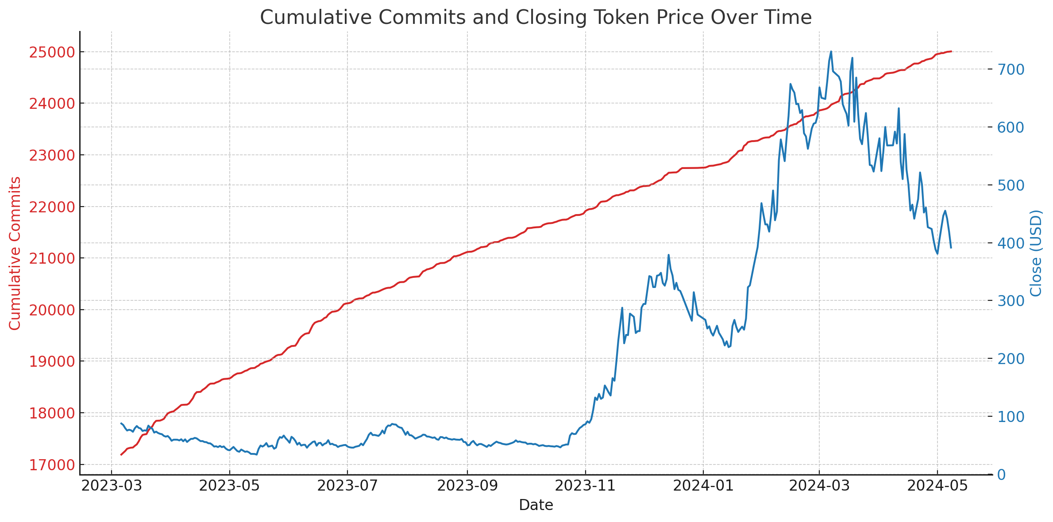

Scatter plot showing the relationship between cumulative commits and token closing prices for the entire period.

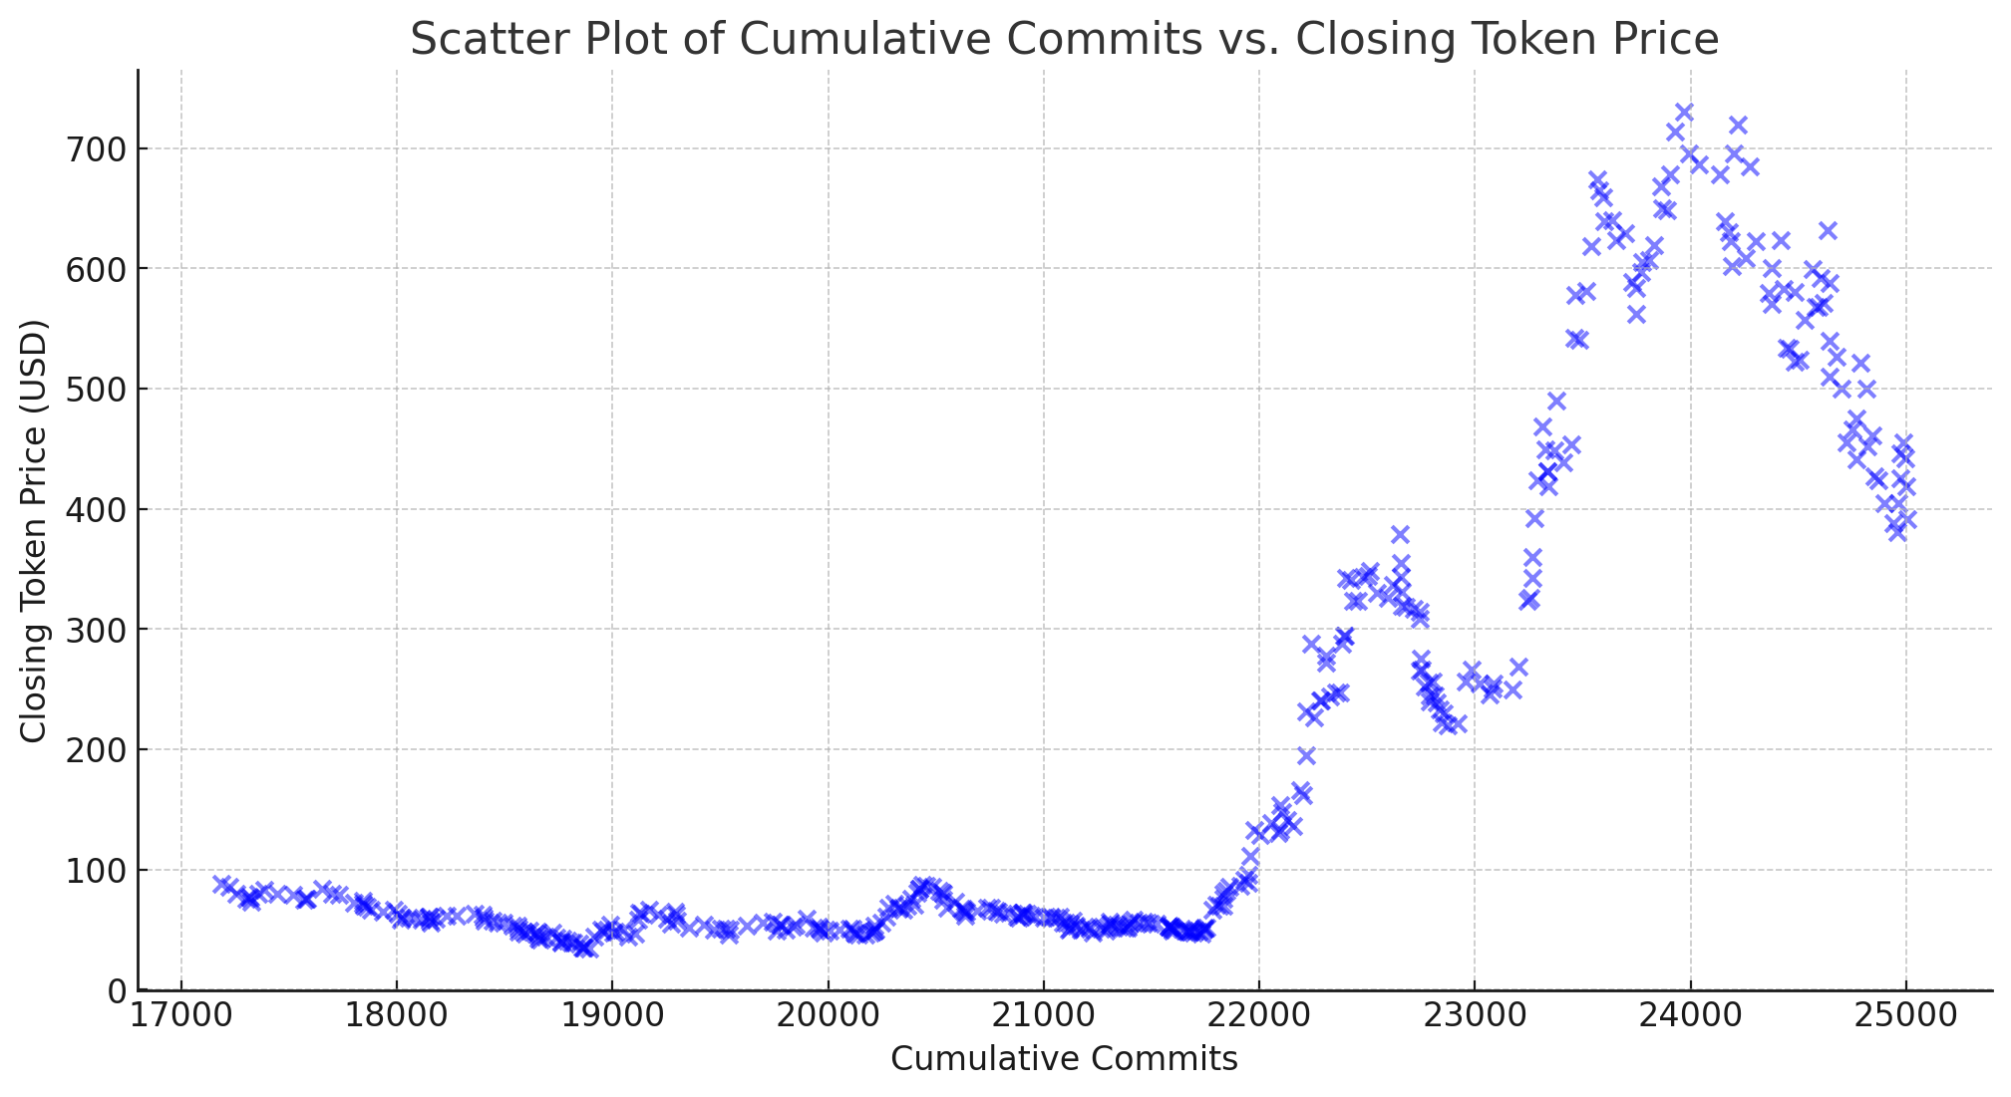Line graphs for both cumulative commits and token closing prices over time to visually inspect trends and their alignment.

Here are the visualizations for Bittensor:

* 1. Scatter Plot: Displays the relationship between cumulative commits and closing token prices. The positive trend supports the strong correlation found in the long-term analysis, showing that as developer activity increases, token prices generally rise.
  2. Line Graphs: These dual-axis line graphs display both cumulative commits and closing token prices over time. The two metrics show aligned growth over the long-term, despite some divergences in the short-term and medium-term, which corresponds to the negative correlations observed in those periods.

These visualizations help illustrate how developer activity and token prices are related and how this relationship varies over different timeframes.

**OCEAN**

For Ocean Protocol, the correlation results between cumulative commits and the closing token price are as follows:

* Overall Long-term Correlation: 0.26
* Short-term Correlation (Last 1 month): −0.54
* Medium-term Correlation (Last 3 months): 0.49

These findings indicate:

* 1. A modest positive correlation over the long term, suggesting a weak relationship where increases in developer activity are slightly associated with increases in token price.
  2. A negative correlation in the short term, implying that recent developer activity might be inversely related to token price movements.
  3. A moderate positive correlation in the medium term, aligning with the long-term trend but stronger.

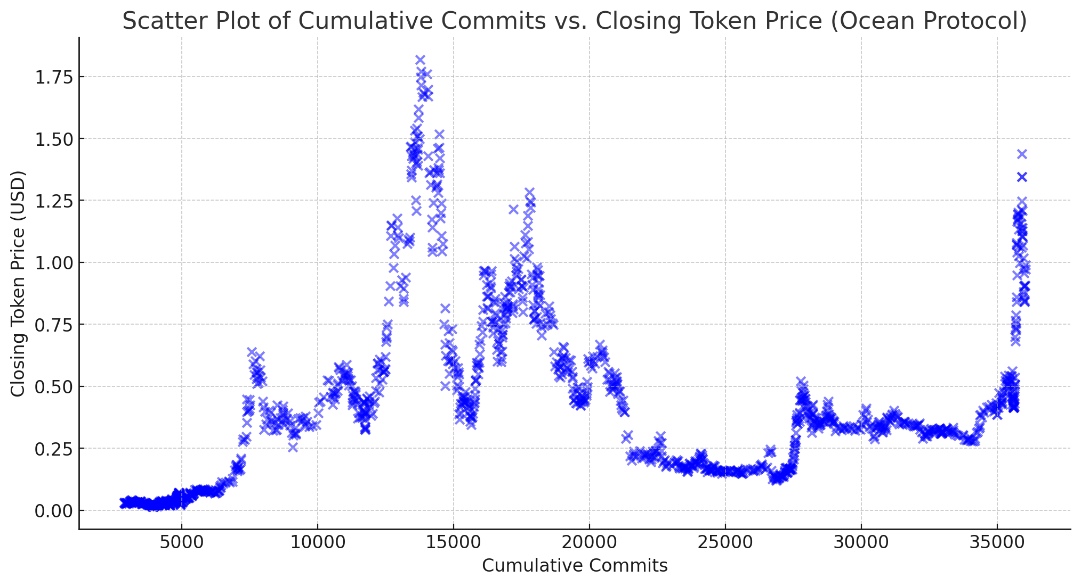

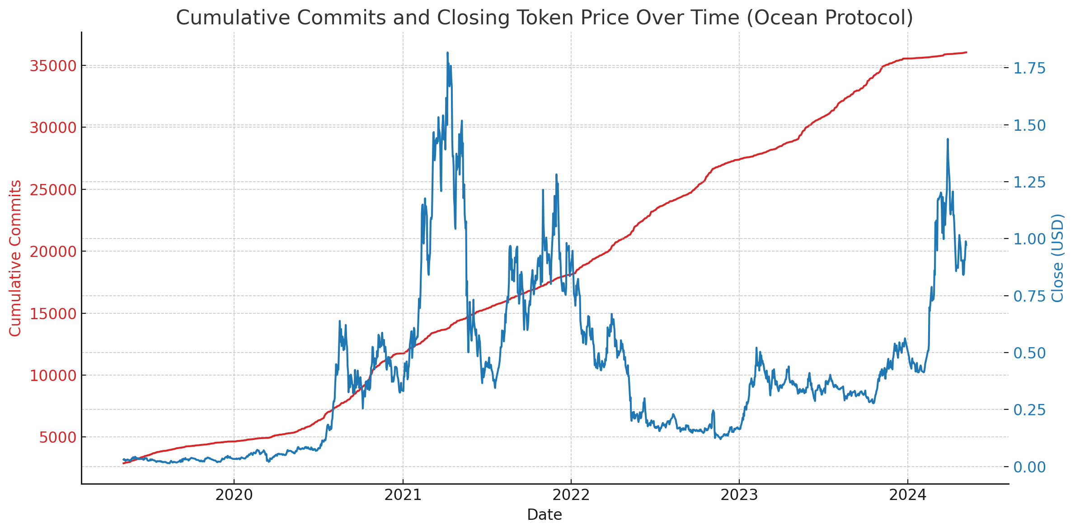

Here are the visualizations for Ocean Protocol:

1. Scatter Plot: Shows the relationship between cumulative commits and closing token prices. The spread indicates the modest overall correlation observed in the data.
2. Line Graphs: These graphs depict cumulative commits and closing token prices over time. The visuals help illustrate the differing correlation strengths over the short-term, medium-term, and long-term, reflecting the diverse impact developer activity may have on token price across different periods.

**SingluarityNET**

For SingularityNET, the correlation results between cumulative commits and the closing token price are as follows:

* Overall Long-term Correlation: 0.400.40
* Short-term Correlation (Last 1 month): −0.34−0.34
* Medium-term Correlation (Last 3 months): 0.420.42

These findings show:

* 1. A moderate positive correlation over the long term, indicating a somewhat consistent relationship between developer activity and token price increases.
  2. A negative correlation in the short term, suggesting that recent developer activities might be inversely related to token price movements.
  3. A similar moderate positive correlation in the medium term, aligning with the long-term trend but slightly stronger.

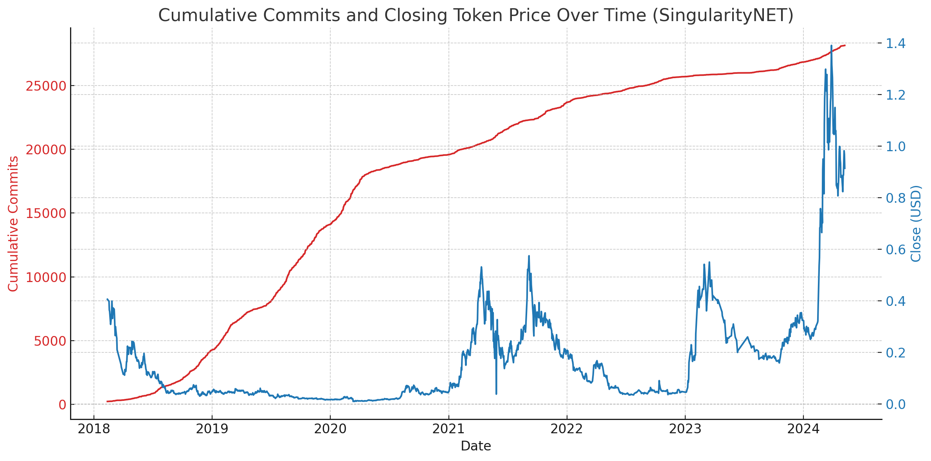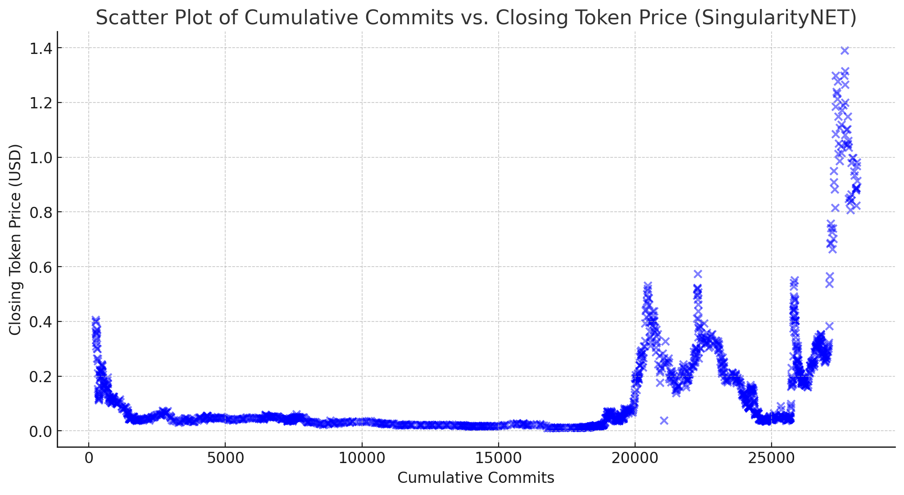

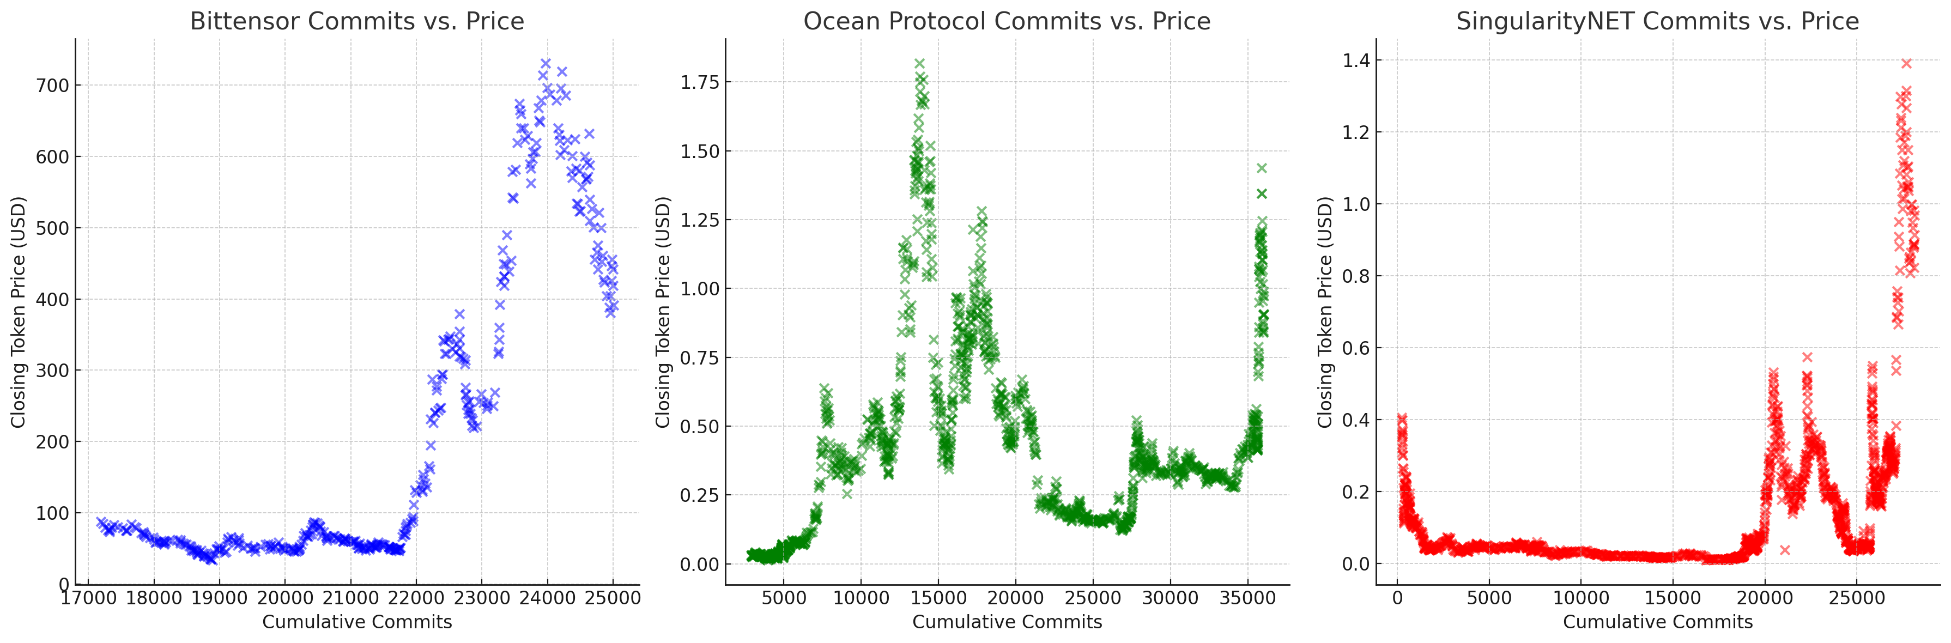

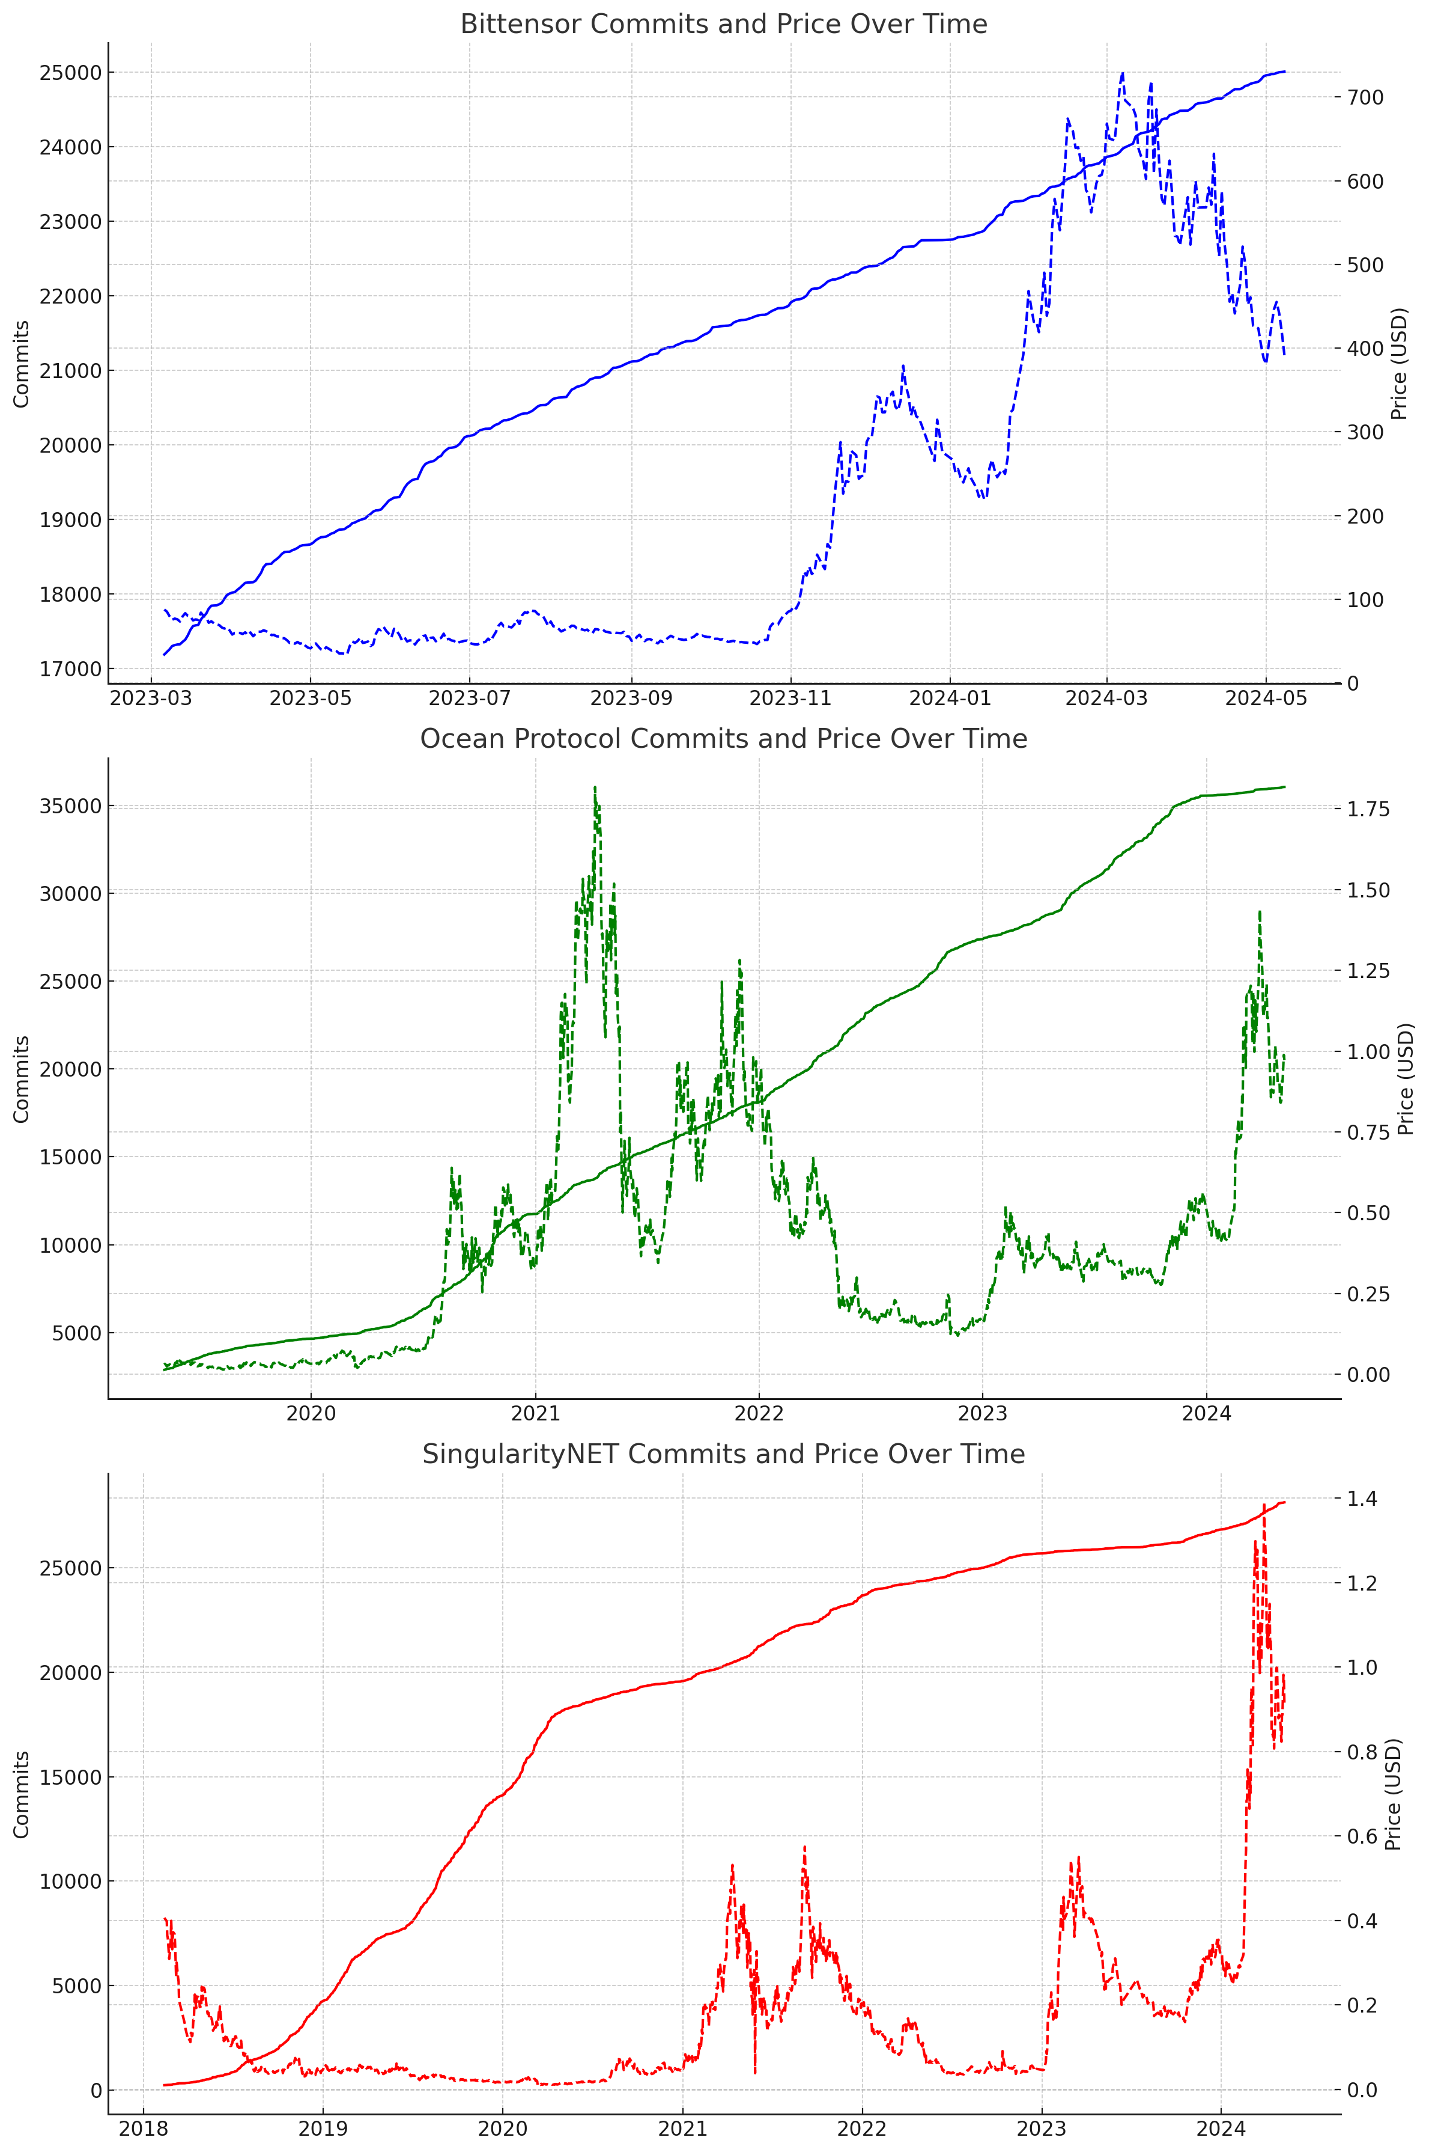

Here are the Pearson correlation coefficients for the three new projects:

1. Fetch.ai: 0.38
2. Numerai: 0.26
3. Oraichain: −0.49

These correlations indicate that:

* Fetch.ai and Numerai show a positive relationship between developer activity and token prices, albeit not particularly strong.
* Oraichain exhibits a moderate negative correlation, suggesting that increases in developer activity might correspond to decreases in token price, or vice versa.

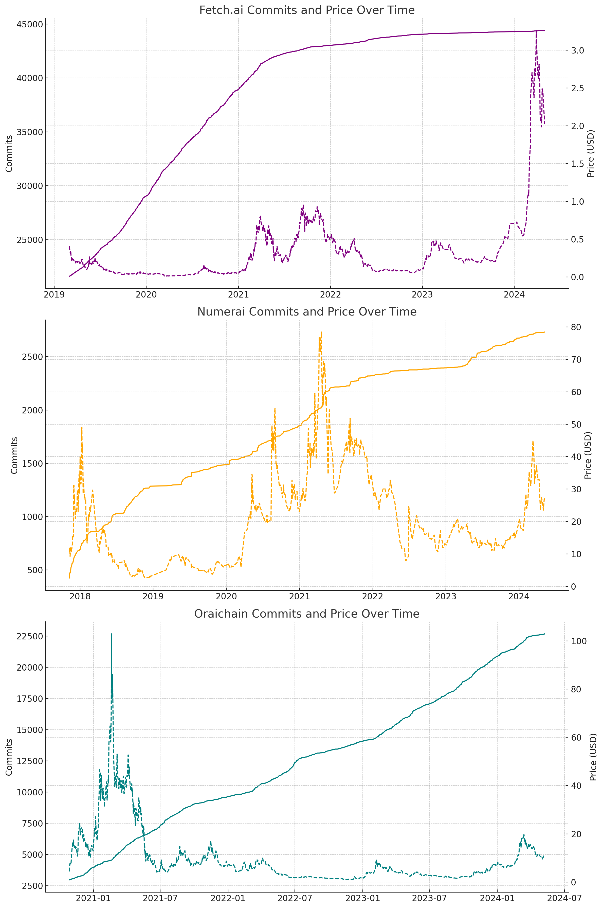 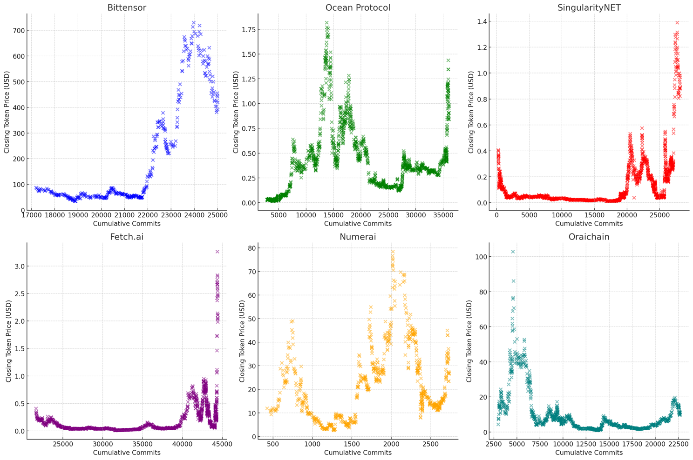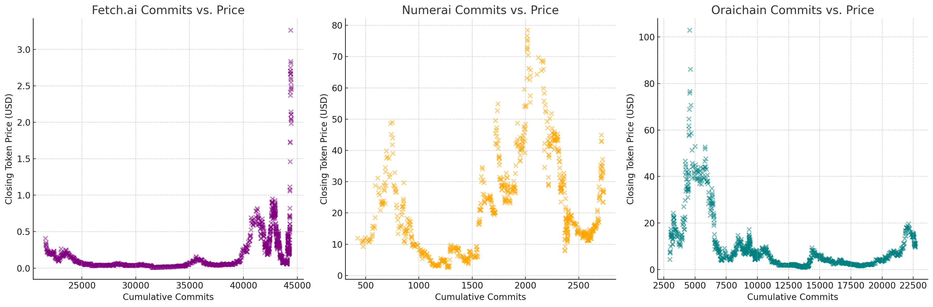

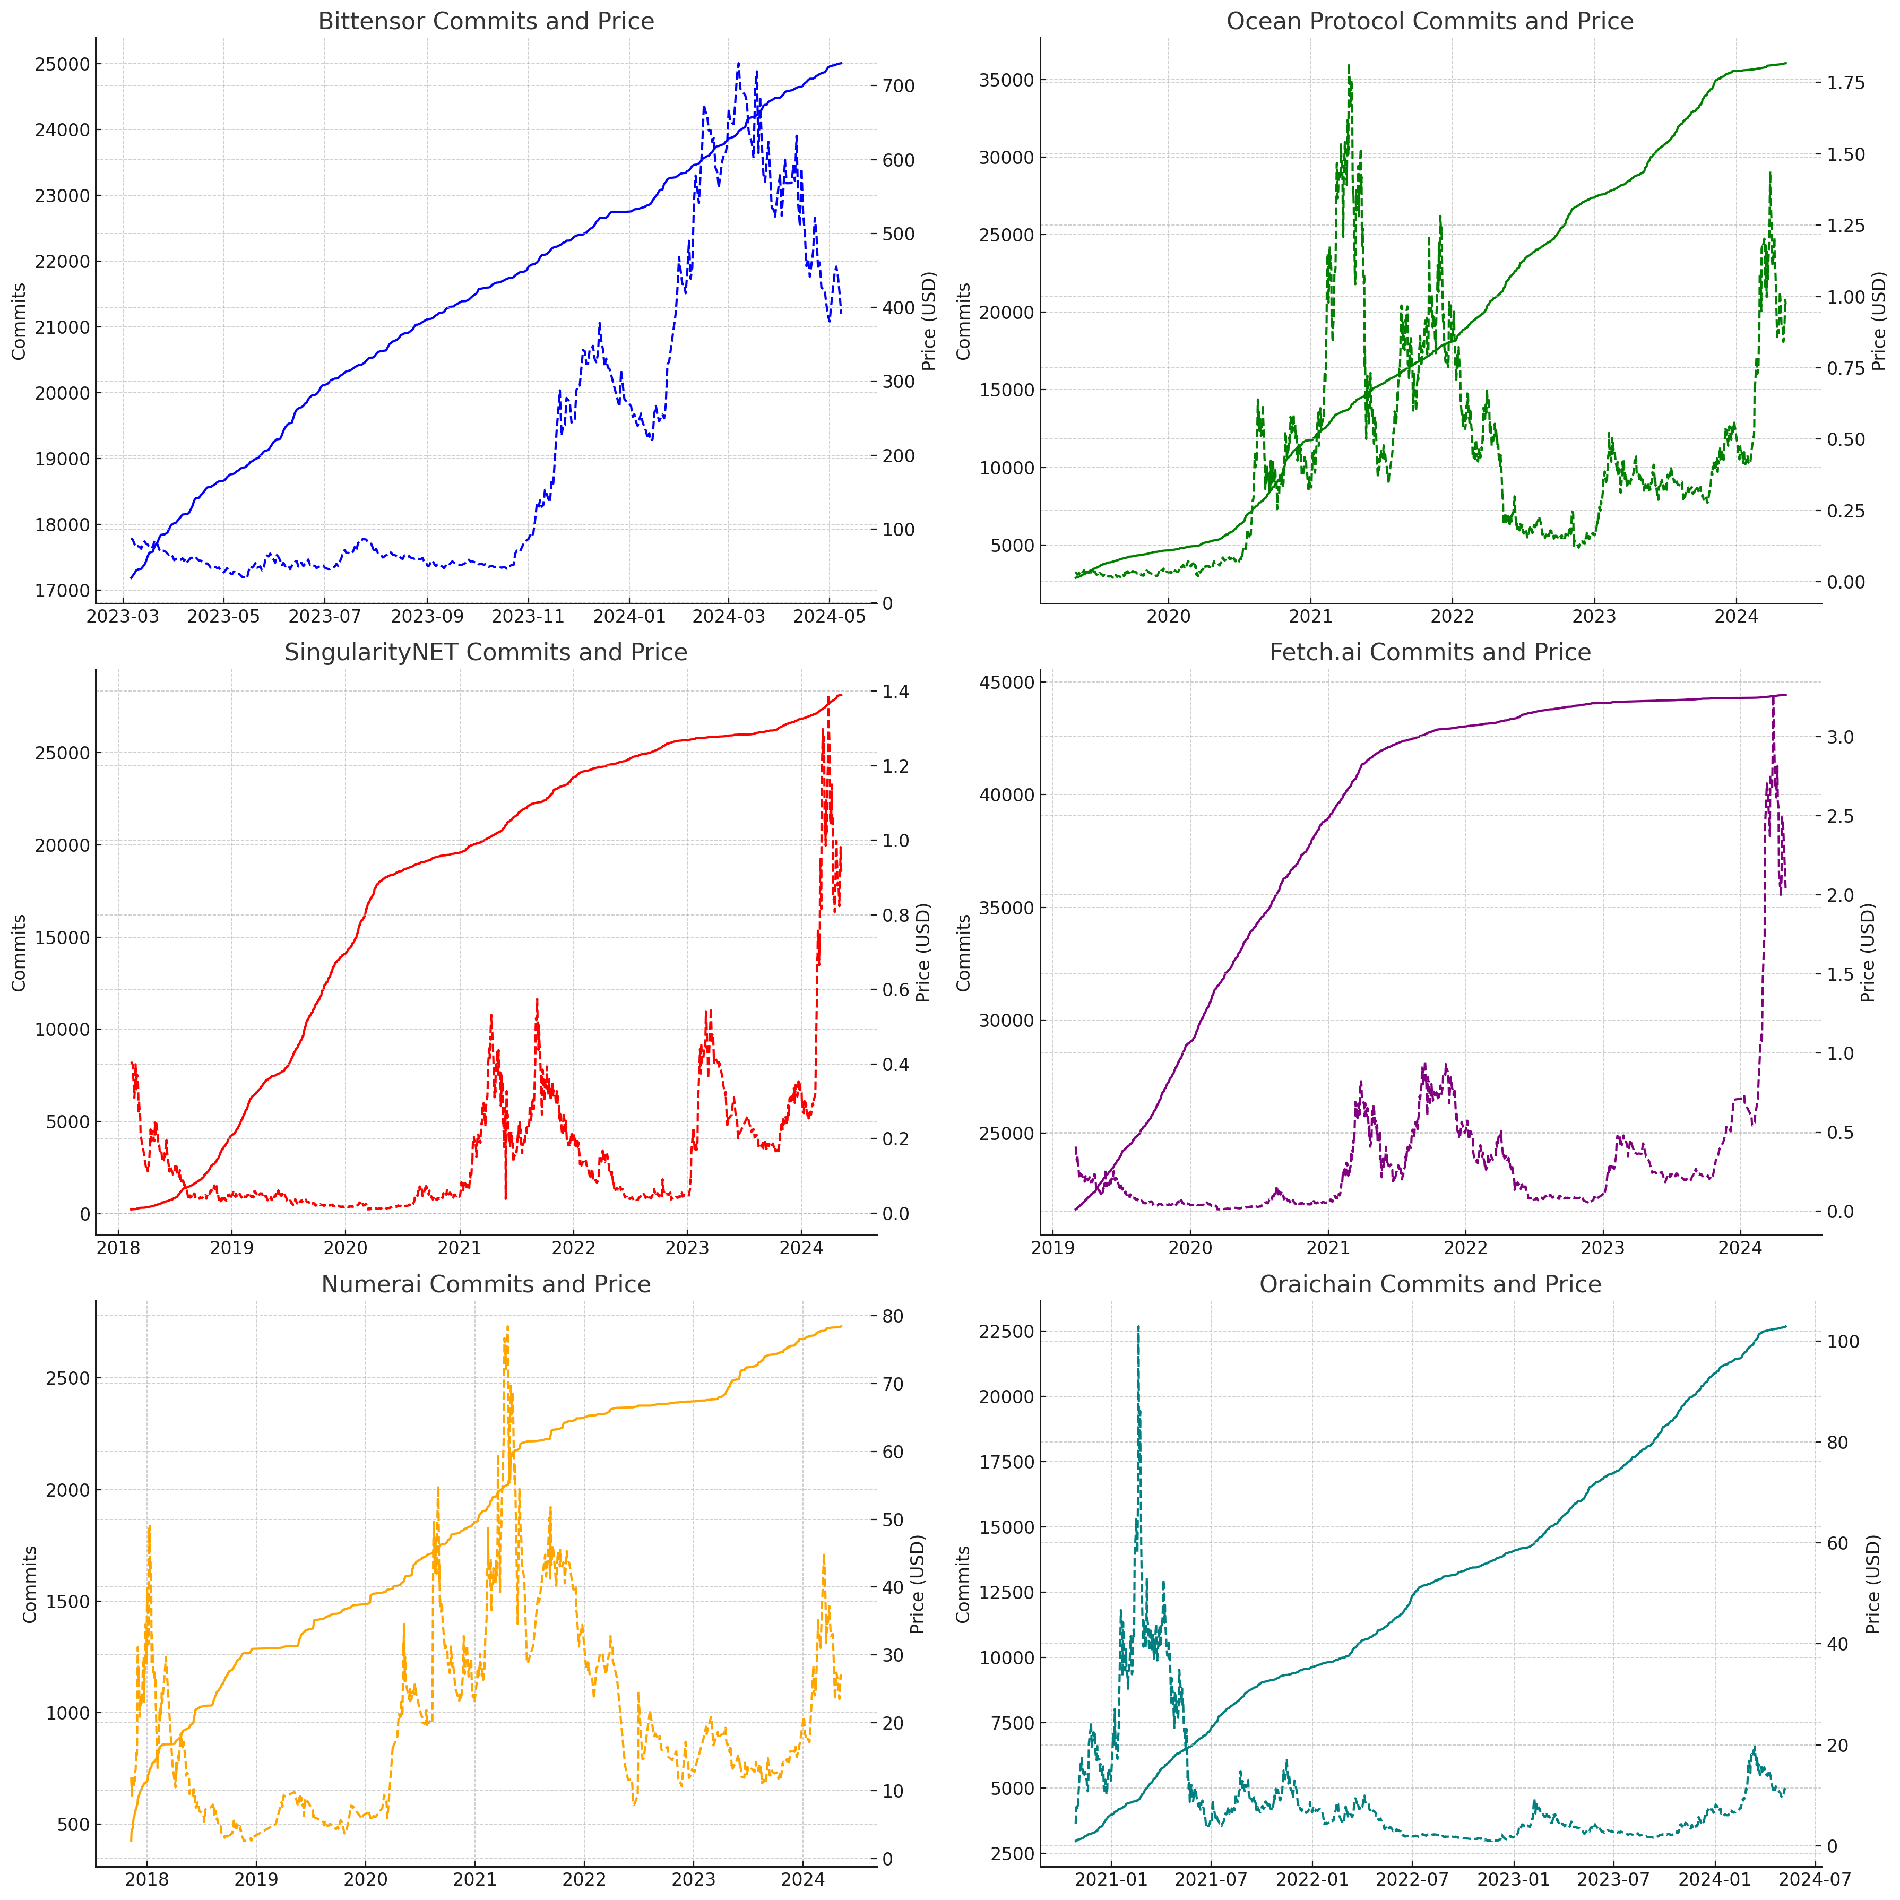

The consolidated line graphs for all six projects are now displayed, arranged with two graphs per row. This layout allows for an effective visual comparison of how developer activity and token prices have evolved over time for each project. Each subplot provides a clear view of the correlation dynamics within that specific project.

To enhance our analysis, I'll calculate the correlation coefficients for each project across different timeframes: short-term (last 1 month), medium-term (last 3 months), and long-term (over the entire dataset). This will help us understand how phases of high or low developer activity impact token prices over these intervals.

| **Project** | **Short-Term Correlation** | **Medium-Term Correlation** | **Long-Term Correlation** |
| --- | --- | --- | --- |
| Bittensor | -0.86 | -0.68 | 0.81 |
| Ocean Protocol | -0.54 | 0.49 | 0.26 |
| SingularityNET | -0.34 | 0.42 | 0.40 |
| Fetch.ai | -0.63 | 0.71 | 0.38 |
| Numerai | -0.16 | -0.01 | 0.26 |
| Oraichain | -0.69 | 0.07 | -0.49 |

**Analysis:**

* 1. Bittensor exhibits strong long-term positive correlation but shows negative correlations in the short- and medium-term, suggesting that developer activity impacts the token price positively over time, though there may be immediate adverse reactions or other influencing factors in the shorter frames.
  2. Ocean Protocol and SingularityNET show variability, with short-term negative correlations but positive in medium and long terms, indicating potential delayed market responses to development activities.
  3. Fetch.ai displays significant medium-term positive correlation after negative short-term correlation, suggesting immediate developer activity could initially be viewed negatively, or other factors might drive prices down temporarily.
  4. Numerai shows relatively weak correlation across all timeframes, suggesting minimal impact of developer activity on token prices.
  5. Oraichain shows a consistently negative correlation, especially over the long term, indicating that increased developer activity might be associated with decreased token prices.

